Short Description
Cup Sealer
Sealing Diameter 70, 75, 90 & 95 mm
500-600 cups / Hr (Plastic material only)
Country of origin: China

Specifications
- Weight (Approx.) : 9 kg
- Voltage : 220 V
- Frequency : 50 Hz
- Power : 200 W
- Sealing Diameter : 70, 75, 90 & 95 mm
- Capacity : 500-600 cups/Hr
- Dimensions (L x W x H) : 260 x 240 x 650 mm

Description
This machine can seal the single cups one by one, and the manual cup sealing machine is suitable for shops to seal cup noodles, fruit jelly, pudding, bean milk, hot & cold food, tea, etc. This sealing machine is made of high quality material which has makes it rust proof and durable. It has 70, 75, 90, and 95 mm sealing diameter.

Features
:
- High performance along with good quality.
- Easy to operate and maintain.
- Budget friendly machine
- Compact size and light in Weight

Applications
:
- Food and Beverage Service : The manual cup sealing machine is widely used in cafes, restaurants, and food stalls to seal beverages like bubble tea, smoothies, and juices. This ensures that drinks remain fresh and spill-proof during transport.
- Takeaway and Delivery Services : It is ideal for businesses offering takeaway services, as the airtight seals prevent leaks and maintain the quality of the food or drink during delivery.
- Event Catering : The machine can be utilized in catering services for events to prepare individual servings of drinks or desserts, enhancing presentation and convenience for guests.
- Food Packaging : In small-scale food production or artisanal businesses, this machine helps in packaging products securely to extend shelf life and ensure hygiene.

Usage
:
- Prepare the Machine : Ensure the machine is clean and all parts are in good condition, plug in the machine and turn it on.
- Set the Diameter : Adjust the diameter setting on the machine to match the size of the cup you will be sealing (70mm, 75mm, 90mm, or 95mm).
- Prepare the Cup : Fill your cup with the desired beverage or food item, leaving some space at the top for sealing.
- Position the Cup : Place the cup with the lid/film into the designated area of the sealing machine.
- Seal the Cup : Press down on the handle to activate the sealing process. Ensure that you apply consistent pressure.
- Check Seal Quality : Once sealed, carefully remove the cup from the machine and inspect it to ensure that there is a secure and airtight seal.
- Clean Up : After use, clean any residue from around the sealing area and ensure all components are ready for next use.

Maintenance :
- Regular Cleaning : After each use, clean the sealing area and any parts that come into contact with food or beverages.
- Inspect Sealing Films : Check the sealing films for any damage or defects before use.
- Storage Conditions : When not in use, store the machine in a dry place away from direct sunlight to prevent damage to its components.

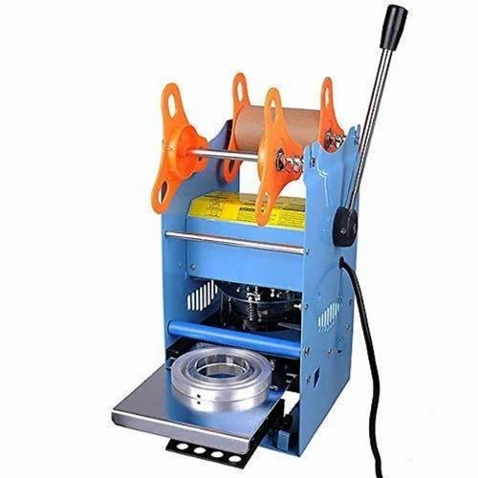

MAKE PDF FOR THIS & ADD TO IT ON THE SAME PAGE

